**Course code: INFS1603**

**Tutorial session (**T18A**):**

**Week number (**Week 2**):**

**Full Name:** Jason Khu

**zID:** 5254974

**\*Notes** **for submission:** write SQL script in doc and then screenshot the output

**Student Solution(s):**

Lab Week 1 Homework – Part A – Basic SQL SELECT statements

Hands-on Assignment

1. Display a list of all data contained in the BOOKS table.

SELECT *

FROM zjlb_books;

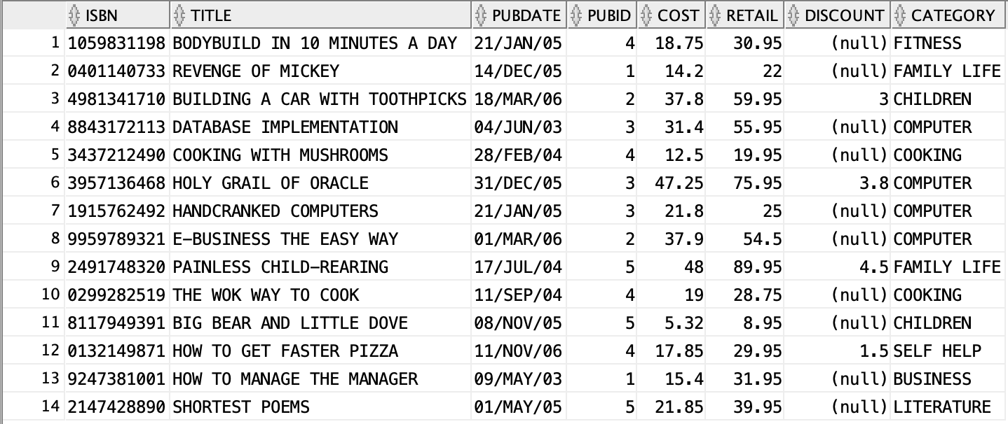

1. List the title and publication data for each book in the BOOKS table. Use the column heading “Publication Date” for the Pubdate field.

SELECT title, pubdate AS "Publication Date"

FROM zjlb_books;

1. Create a list containing the publisher’s name, the person usually contacted, and the publisher’s telephone number. Rename the contact column “Contact Person” in the displayed results.

SELECT name, CONTACT as "Contact Person", PHONE

FROM zjlb_publisher;

1. List the customer number from the ORDERS table for each customer who has placed an order with the bookstore. List each customer only once.

SELECT DISTINCT customer#

FROM zjlb_orders;

1. Create a list of authors that displays the last name followed by the first name for each author. The last names and first should be separated by a comma and a blank space.

SELECT lname || ', ' || fname

FROM zjlb_author;

1. List all information for each order item. Include an item total, which can be calculated by multiplying the Quantity and Paideach columns. Use a column alias for the calculated value to show the heading “Item Total” in the output.

SELECT order#, item#, isbn, quantity, paideach, quantity * paideach AS "Item Total"

FROM zjlb_orderitems;

Lab Week 1 Homework – Part B – Restricting Rows and Sorting Data

Hands-on Assignment

1. List each customer’s last name, first name, and state.

SELECT lastname, firstname, state

FROM zjlb_customers;

1. Which books aren’t in the Fitness category? List each book title and category.

SELECT title, category

FROM zjlb_books

WHERE category <> ‘FITNESS’;

1. Which orders were placed on or before April 1, 2009? List each order number and order date. Write this query two different ways.

SELECT order#, orderdate

FROM zjlb_orders

WHERE orderdate <= '01/APR/09';

SELECT order#, orderdate

FROM zjlb_orders

WHERE orderdate < '01/APR/09' OR orderdate = '01/APR/09';

1. List all customers who were referred to the bookstore by another customer. List each customer’s last name and the number of the customer who made the referral.

SELECT lastname, referred

FROM zjlb_customers

WHERE referred IS NOT NULL;

1. Use a search pattern to find any book title with “A” for the second letter and “N” for the fourth letter. List each book’s ISBN and title. Sort the list by title in descending order.

SELECT isbn, title

FROM zjlb_books

WHERE title LIKE '_A_N%'

ORDER BY title DESC;

1. List the title and publish date of any computer book published in 2005. Perform the task of searching for the publish date by using three different methods: a) a range operator, b) a logical operator, and c) a search pattern operation.

SELECT title, pubdate

FROM zjlb_books

WHERE category = 'COMPUTER' AND pubdate BETWEEN '01/JAN/05' AND '31/DEC/05';

SELECT title, pubdate

FROM zjlb_books

WHERE category = 'COMPUTER' AND pubdate BETWEEN '01/JAN/05' AND '31/DEC/05';

SELECT title, pubdate

FROM zjlb_books

WHERE category = 'COMPUTER' AND pubdate LIKE '%/05';

